Purpose: The purpose of this activity is to practice writing SQL DDL and DML statements.

Tasks:
- Given the following database design, create the database with appropriate tables and relationships established using MySQL Workbench. Note that the design consists of foreign keys, but does not identify them clearly.
- Other details:
  - CustomerID is a surrogate key
  - EmployeeID is a surrogate key
  - VendorID is a surrogate key
  - ItemID is a surrogate key
  - SaleID is a surrogate key in SALE
  - All entities except SALE_ITEM are strong. So, all relationships are non-identifying. This design was created using Access and Access does not use dotted lines.
  - SALE_ITEM is an ID-dependent entity and depends on SALE for its existence.

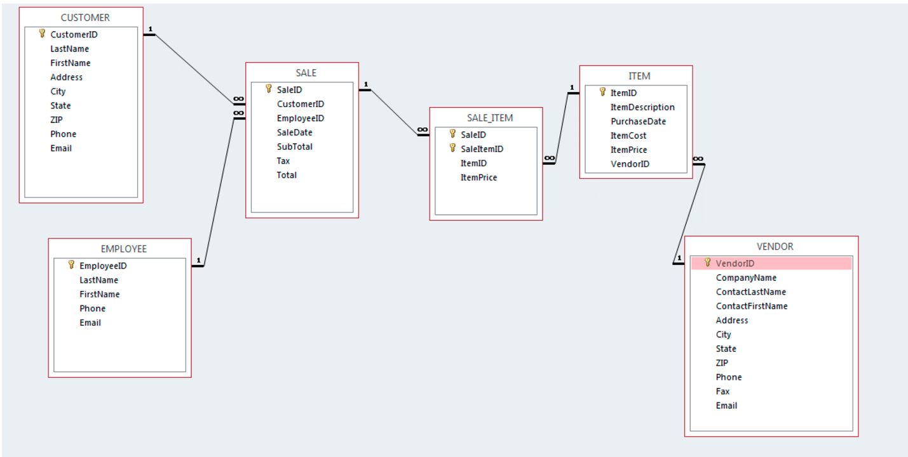
- If you have any questions about the tables, please ask.
- Use MySQL-QACS-Insert-Data.sql script to run the statements that insert data into these tables. When you get errors, read them carefully and see if they can be resolved. If not, feel free to ask your instructor or classmates or AEC tutors.
- Once database and tables are created and data is inserted in the tables, write SQL queries as specified below. Each query should be identified correctly by using comments. Submit all .sql files on D2L when done.

Queries:
- Write a SQL statement that will list the ItemID and ItemDescription for all items that have an item cost that is greater than or equal to 3000.
- Write a SQL statement that will list the ItemNumber and ItemDescription for all items that have an item cost that is $1000 or more and starts with the item description ‘Antique’.

- Write a SQL statement that will list the CompanyName, Address and Phone for vendor companies that do not have a NULL value in the company name.

- Write a SQL statement that will list the employee LastName, FirstName, Phone and Email in ascending order by FirstName for employees who have the characters “Stuart” after the . in the email address. So, it should list Anne.Stuart@QACS.com since the characters Stuart is present after the dot.

- Write a SQL statement that will list the ItemID, PurchaseDate, ItemCost, ItemPrice and a new column called PriceMarkup that is the difference of ItemPrice and ItemCost.

- Use a subquery to write an SQL statement that will list the FirstName, LastName and Phone of customers who made a purchase (Sale Subtotal) of at least $500. Each customer should be listed only once.

- Write a SQL statement that will list the employee FirstName, LastName, Phone, SaleDate, and Subtotal for Employees who have initiated sale subtotals of $3000 and above.

- Write a SQL statement that will list the ItemId, ItemDescription, ItemPrice, CompanyName of vendor of item with ItemID 1.

- Write a SQL statement that will list the Customer LastName, FirstName, Phone with two additional columns- the total number of sales as NumberSalesTransactions and total sum of sales as TotalSalesAmount.

- Write an SQL statement that will list the ItemID and ItemDescription of items that have not had a sale transaction. In other words, items that do not appear in the Sale_Item table.

